Scalability & Future Plan
Date | 06 July 2026
Team ID | SWTID-2026-1999
Project Name | OptiCrop: Smart Agricultural Production Optimization Engine
Maximum Marks | 1 Mark
Scalability & Future Plan:
This document outlines how the current project solution can be scaled to handle larger user bases, increased data loads, or extended features in the future. It also captures the team's roadmap for enhancing and evolving the project beyond its current state.

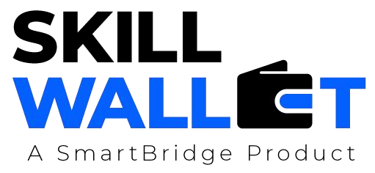
Current System Limitations:
S.No | Limitation | Impact | Priority to Address (High / Medium / Low)
1 | Limited dataset for model training | May reduce prediction accuracy | High
2 | Supports limited crop recommendations | Restricts usability for different regions | Medium
3 | No real-time IoT sensor integration | Cannot provide live field monitoring | High
Scalability Plan:
S.No | Scalability Aspect | Current State | Proposed Upgrade / Solution
1 | User Load | Supports limited users | Deploy on cloud with load balancing for more users.
2 | Data Storage | Uses local database | Upgrade to cloud database for larger storage.
3 | Performance | Suitable for small datasets | Optimize code and ML model for faster predictions.
4 | Security | Basic user authentication | Implement advanced authentication and data encryption.
Future Roadmap:
Phase | Planned Feature / Enhancement | Target Timeline | Expected Impact

Phase 1 | Improve crop prediction accuracy using larger datasets | 3 Months | More accurate recommendations
Phase 2 | Integrate weather API and real-time data | 6 Months | Better farming decisions
Phase 3 | Develop Android mobile application | 9 Months | Increased accessibility for farmers
Phase 4 | Add IoT sensor integration and cloud deployment | 12 Months | Real-time monitoring and scalable system

